Graduate students from various disciplines and institutions participate in the Graduate Writing Institute (GWI) to enhance their academic writing skills and make progress on a personal academic writing project.
The GWI helps participants complete research projects, articles, conference presentations, grant proposals, theses, dissertations, and more.
PROGRAM DETAILS

WRITING WORKSHOPS: Topics related to graduate writing concerns.

WRITING BOOTCAMPS: Facilitated writing time.

FACILITATED TUTORING GROUPS: Groups of 3-4 students meet weekly with a WSIP specialist for document review.

INDIVIDUAL TUTORING: Students meet one-on-one with a WSIP specialist for document review.
Student Testimonial
“I cannot thank you all enough….I feel so encouraged to continue pressing onward on my journey for my Doctorate. This experience was a catalyst for my next steps as a PhD student.”
Graduate Writing Institute

DATES: June 3-21, 2024
LOCATION: In-person and/or Online
COST:
$175 University of Arizona graduate students
$400 Non-University of Arizona students
* The GWI is designed for graduate students, but post-docs interested in developing their writing skills while working to complete a scholarly document are welcome to apply.
APPLICATION DEADLINE:
May 1, 2024 or until filled
Apply online beginning in March.
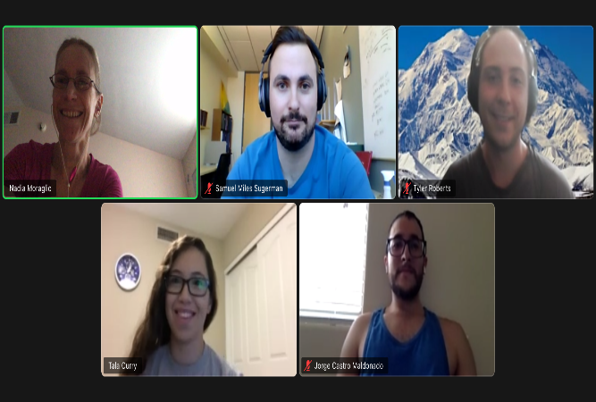
CONTACT: Writing Skills Improvement Program writingskills@arizona.edu
Ph: (520) 621-5849

